COMPLETE WORKFLOW OF GUIDE RNA PREPARATION FOR CRIPSR CAS9 USING EGFR GENE

The complete workflow for designing CRISPR/Cas9 guide RNAs (gRNAs) using a target gene sequence (here: - EGFR), screening candidate guides with CHOPCHOP, and visualizing/editing guides in SnapGene.
Guide RNAs are not directly designed from protein sequences because CRISPR/Cas9 targets nucleic acids (DNA), not amino acid sequences.
If you only have a protein sequence:
- Identify the corresponding gene.
- Obtain the DNA sequence from NCBI or Uniprot.
- Use the DNA sequence for guide RNA design.
Step 1: Obtain the Target Gene Sequence
• Open NCBI Gene database.
• Search for the target gene (example: EGFR).
• Download the sequence in FASTA format.

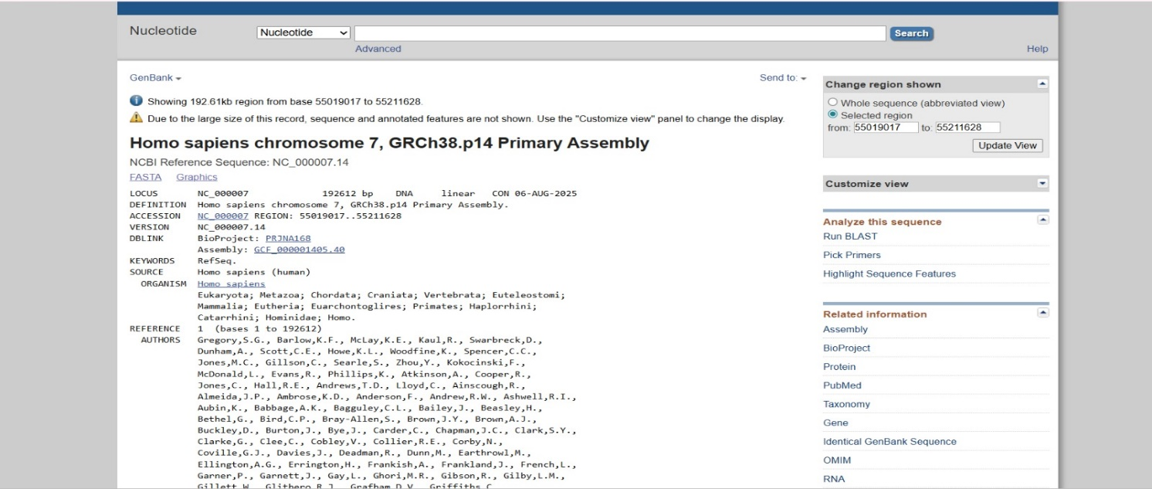

Step 2: Open Sequence in SnapGene
- Open SnapGene.
- Click:File → Open
- Select the FASTA file.
- The sequence will load in linear or circular format.
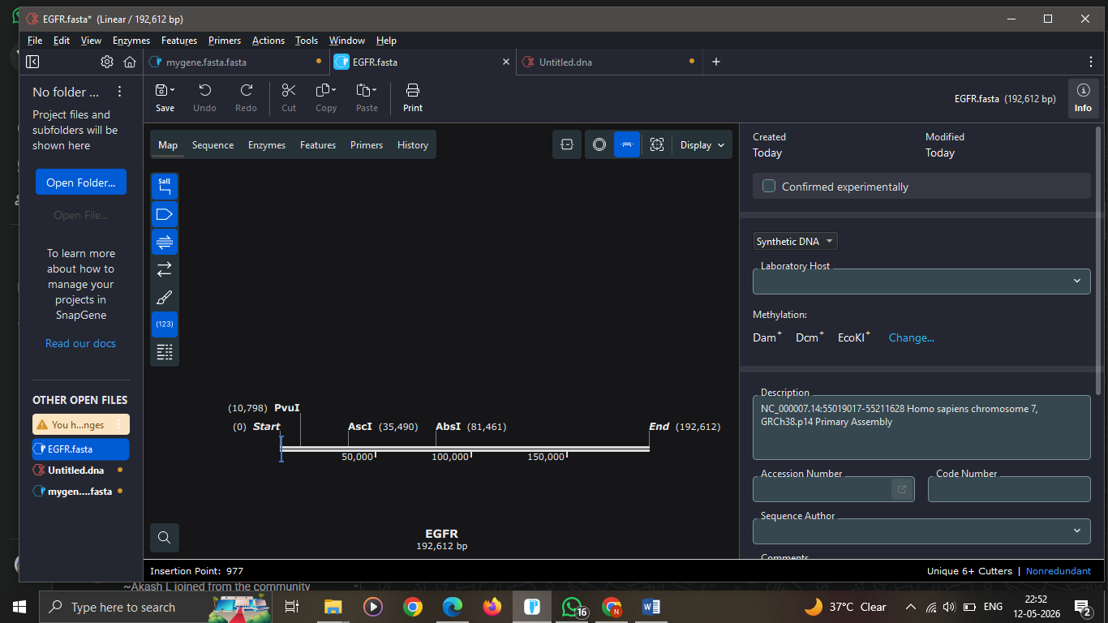

Step 3 : Open CHOPCHOP
Website ; https://chopchop.cbu.uib.no/
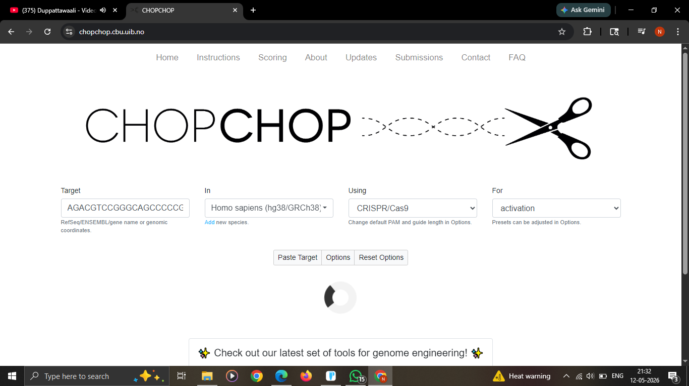

Step 4: Run gRNA Search
Click: Paste Target
CHOPCHOP will:
- Scan PAM sites.
- Predict guides.
- Rank efficiency.
- Estimate off-targets.
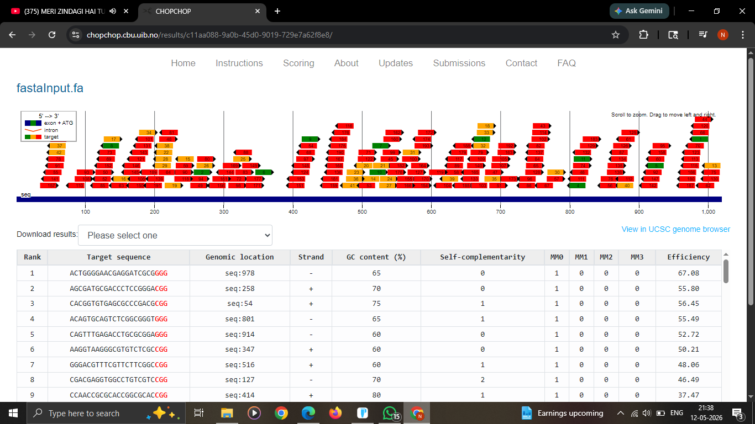
Step 5: Select the Best Guide RNAs
1.High Efficiency – Efficiency > 50
2. Minimal Off-Targets
MM0 - 1
MM1 - 0
MM2 - 0
3.GC Content - 40%–60%
Very low GC:
- weak binding
Very high GC:
- secondary structures
4. Self-Complementarity – 0 (should not be self complementing)
Step 6. Export results in excel
Sort according the value needed.
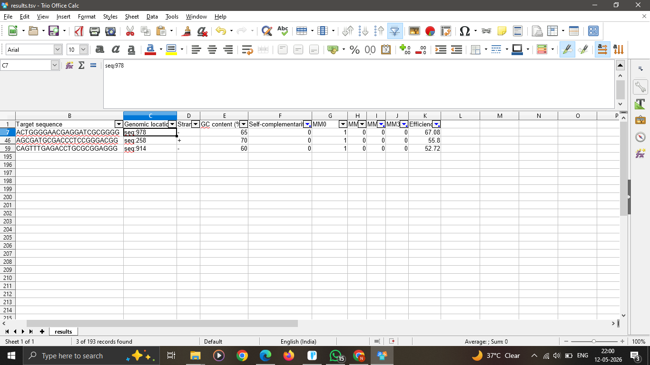
Step 6: Visualize Guides in SnapGene
- Open sequence in SnapGene.
- Go to: Features → Add Feature
- Add guide sequence.
- Mark: Guide RNA region, PAM site
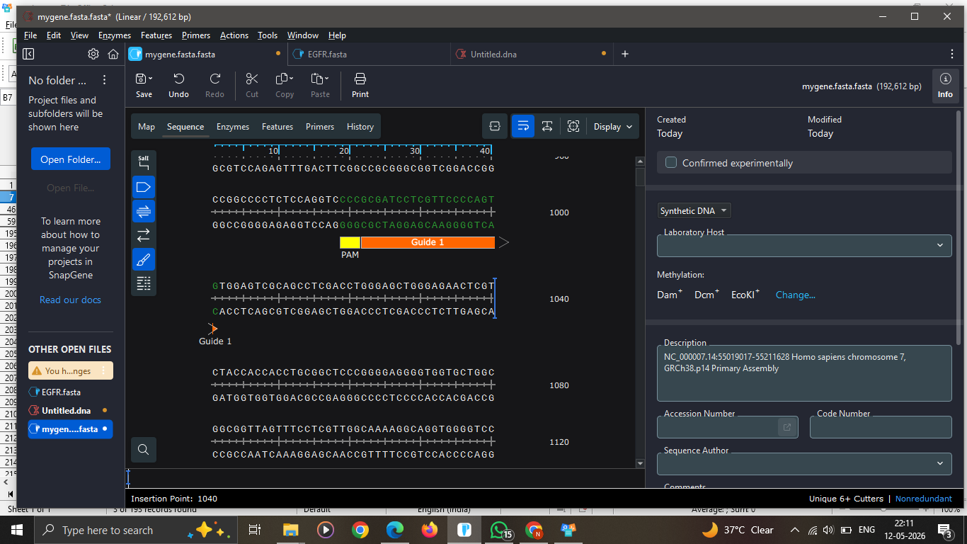\
VALIDATE – USING NEXT GENERATION SEQUENING
We have taken this guide RNA because it fullfills all our criteria including high efficiency, GC content between 40-60%, and MM0 – 1 which means that our guide sequence will hit the target only once.

